
MSD SOP for Azure Storage Sync Services

Overview & Goals.

The “Purpose” of a SOP is to provide detailed instructions on how to setup Azure Storage Sync Services.
Prerequisite
- Window Server 2012,2016,2019,2022
- Azure Storage Account with File Share

Create Storage Service Sync Service

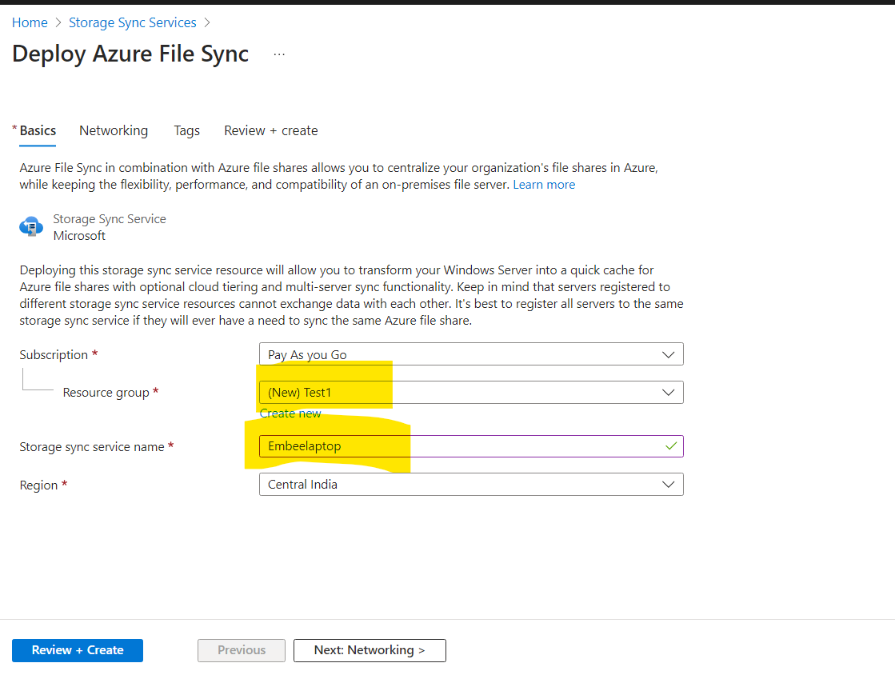

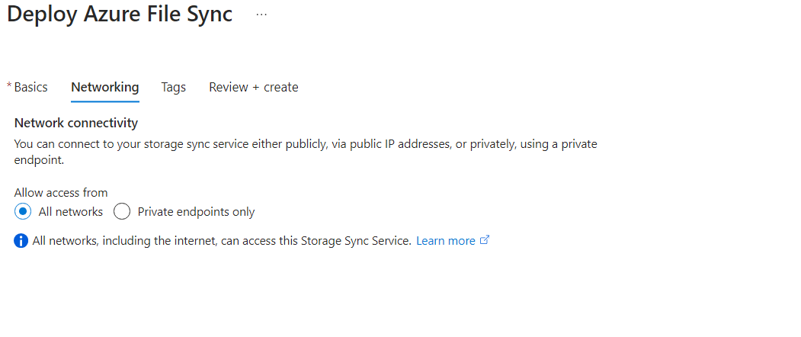
Once the service is installed , go to registered server and download the agent as per server requirement

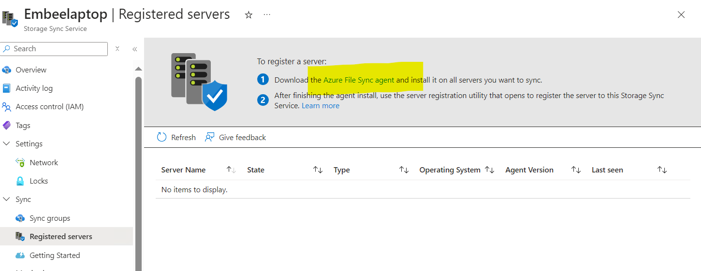

Run the Wizard Agent Wizard
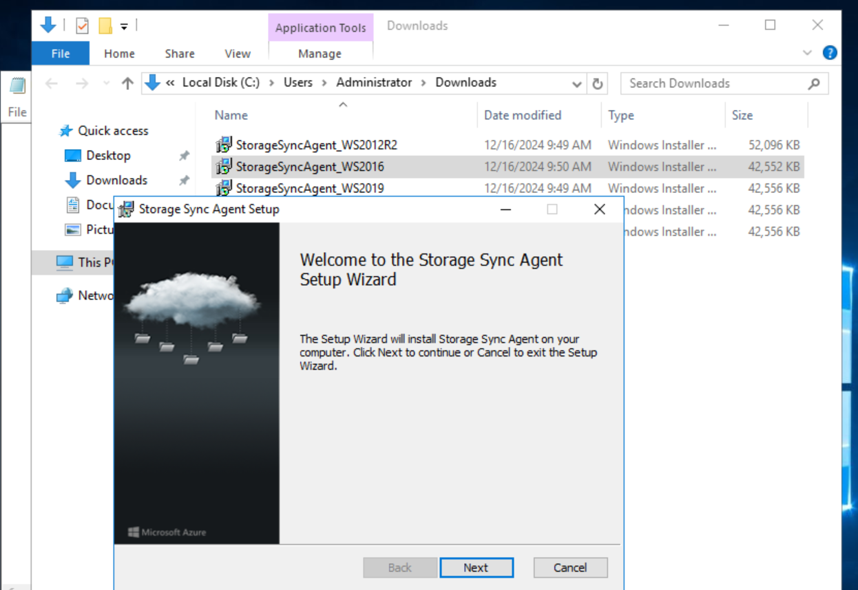

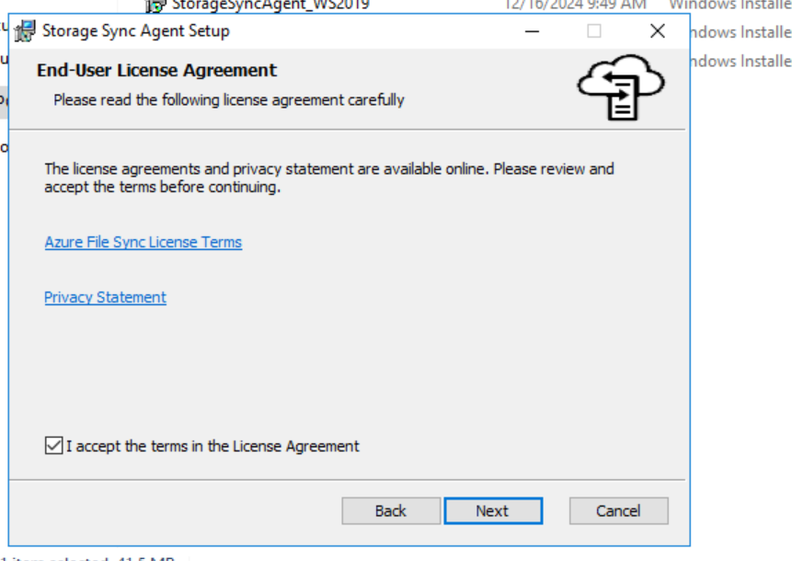

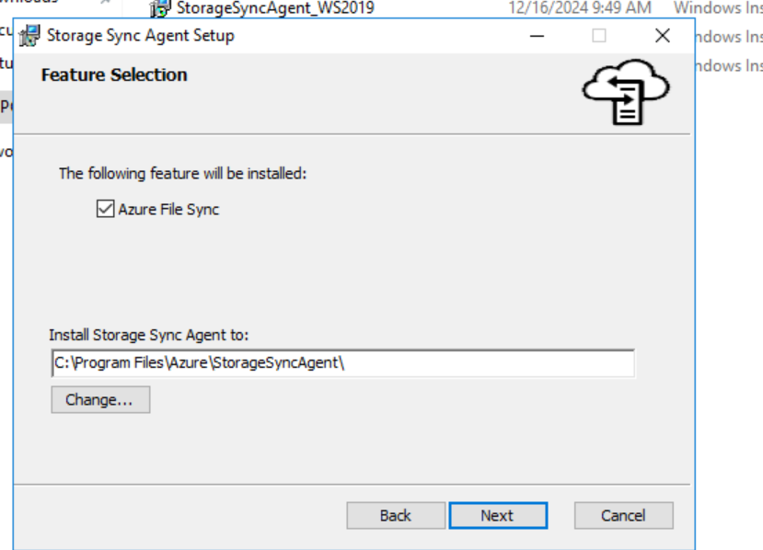

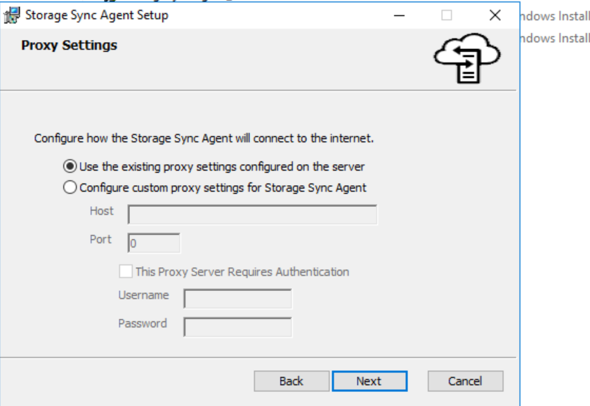

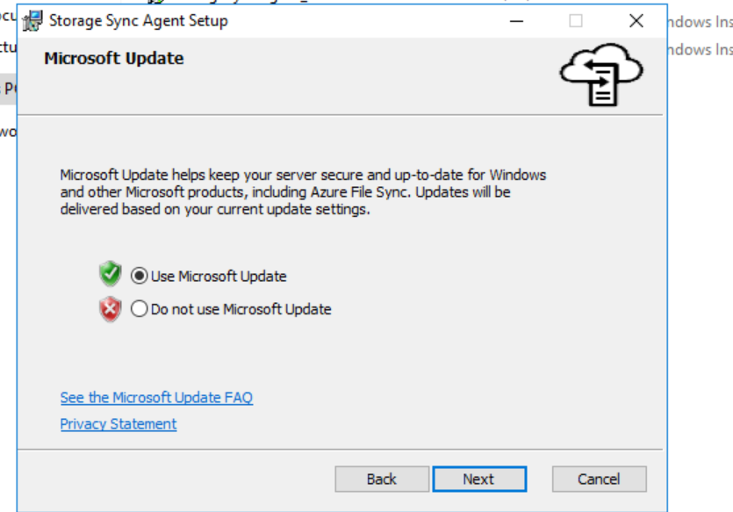

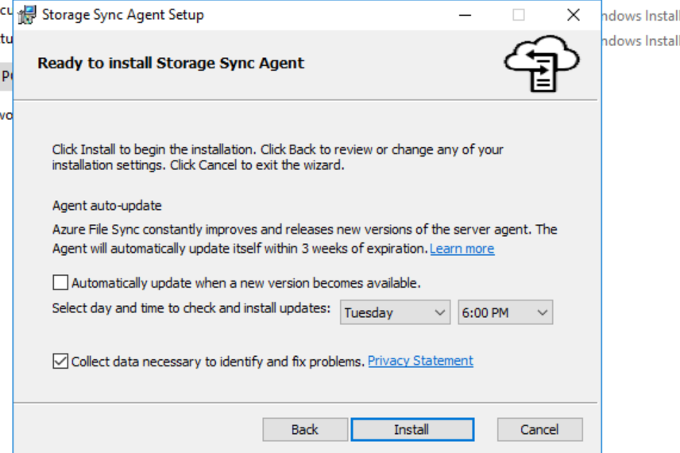

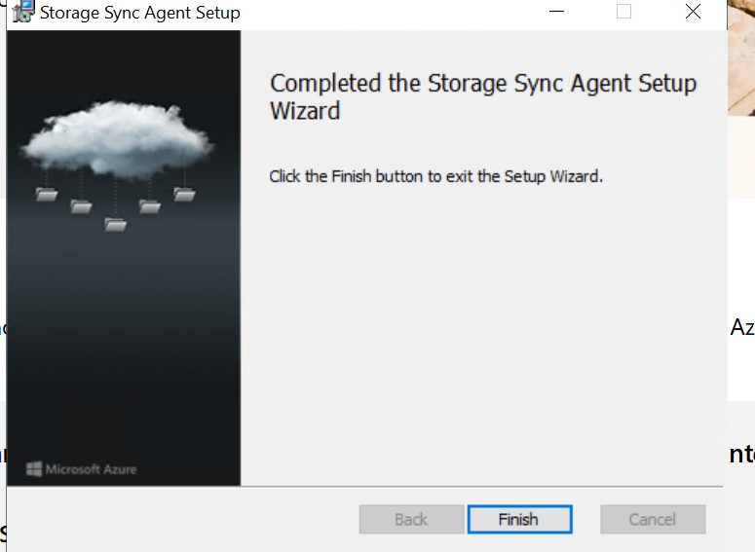

Once the installation is completed , enter the tenant id
And username and ID.

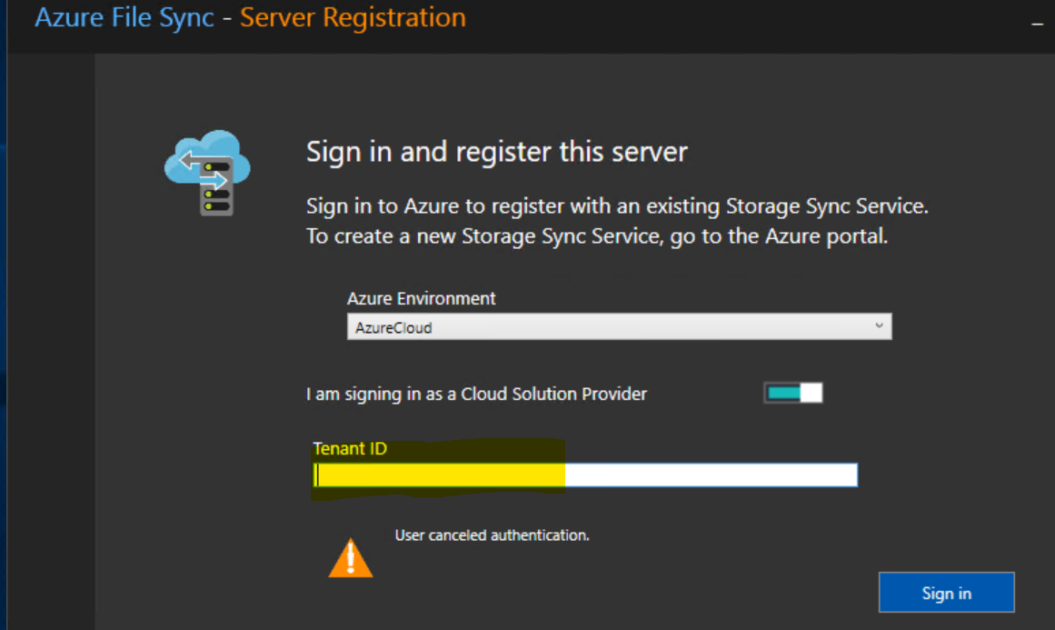

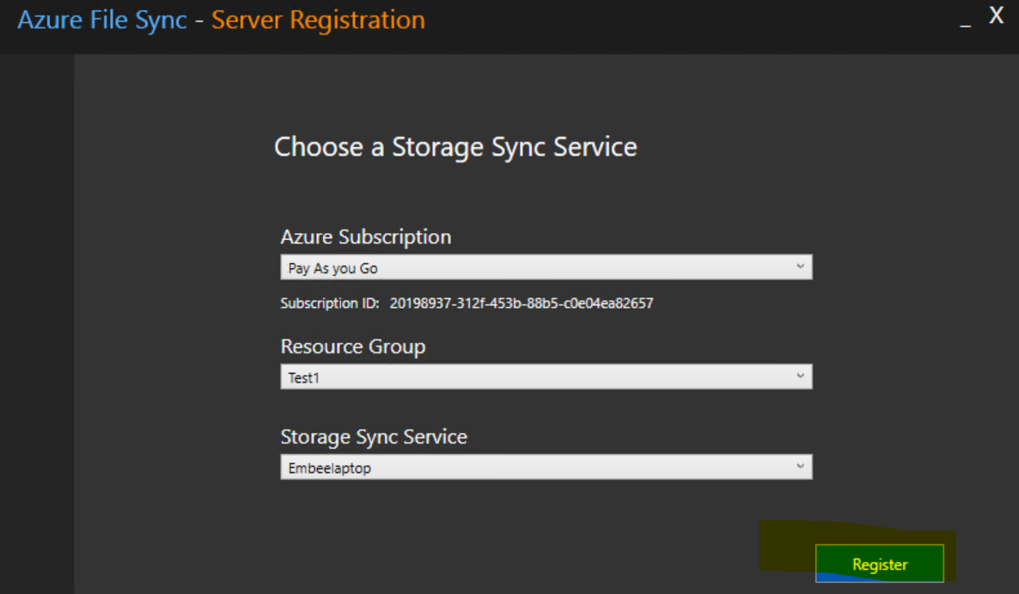

After finishing the registration, go to azure portal and you will be able to see the On premise registered device.

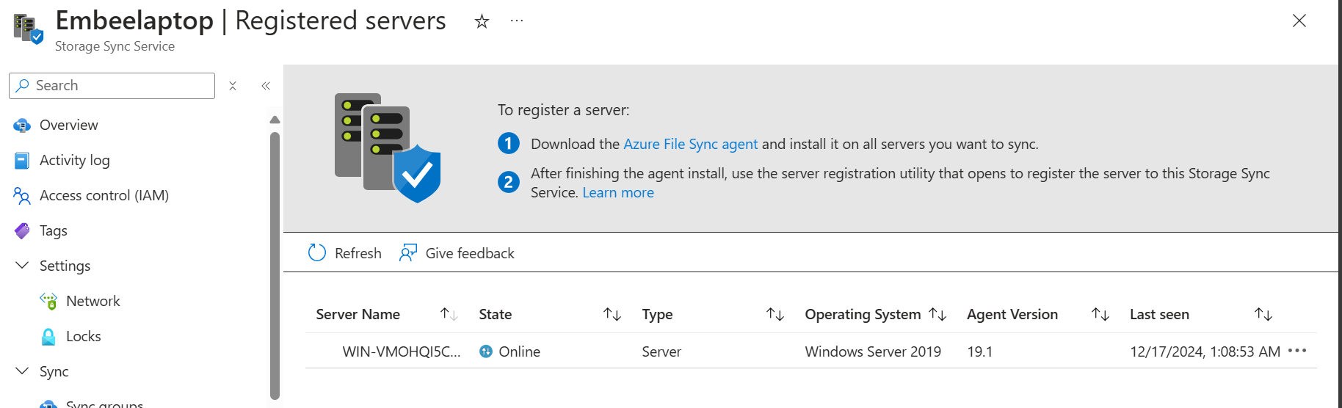

Create the Storage account and file share
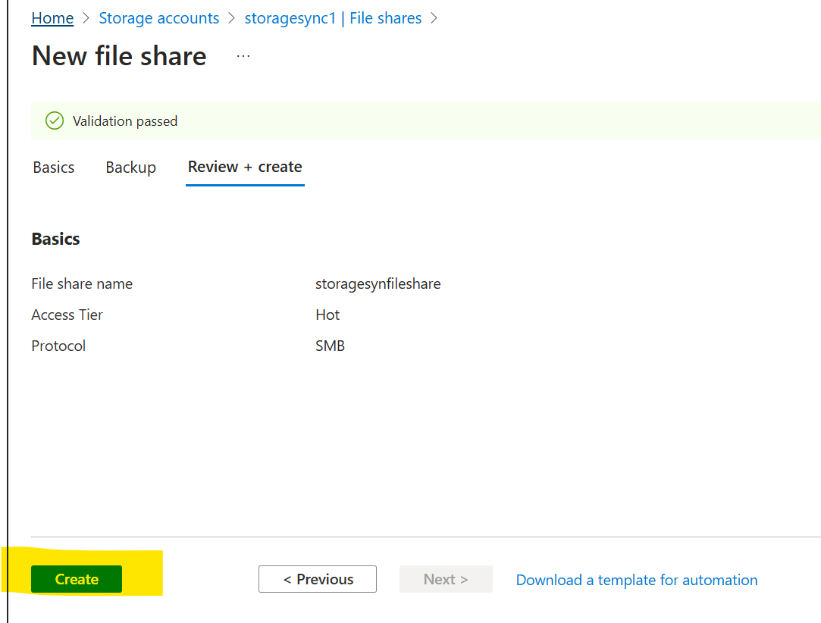

Then Create the Sync group.
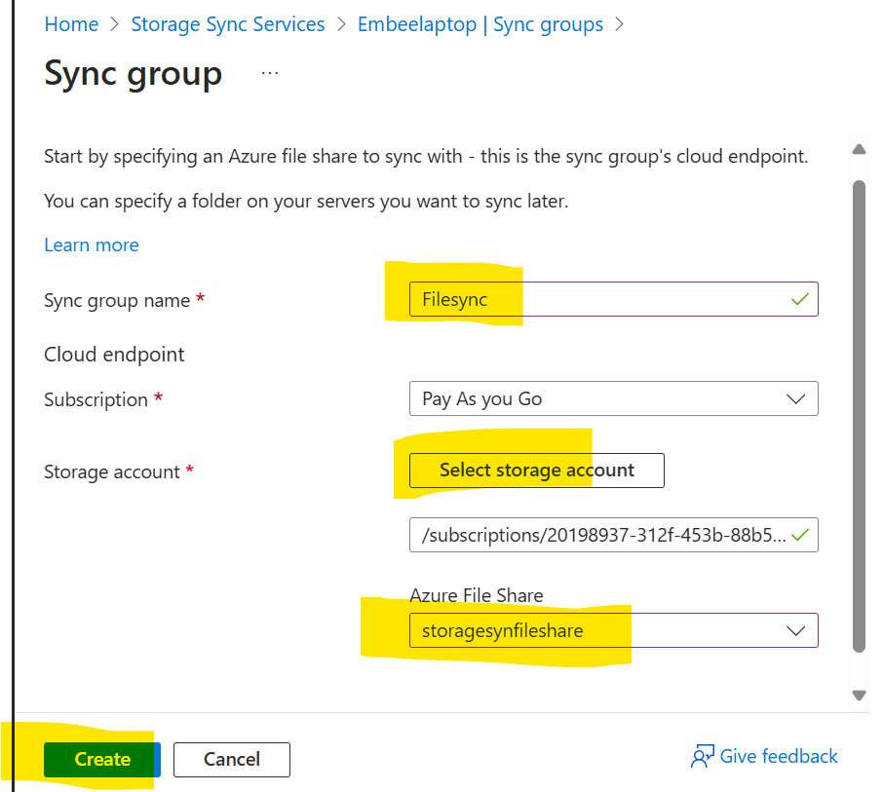

Add cloud endpoint and server end point in Sync group.

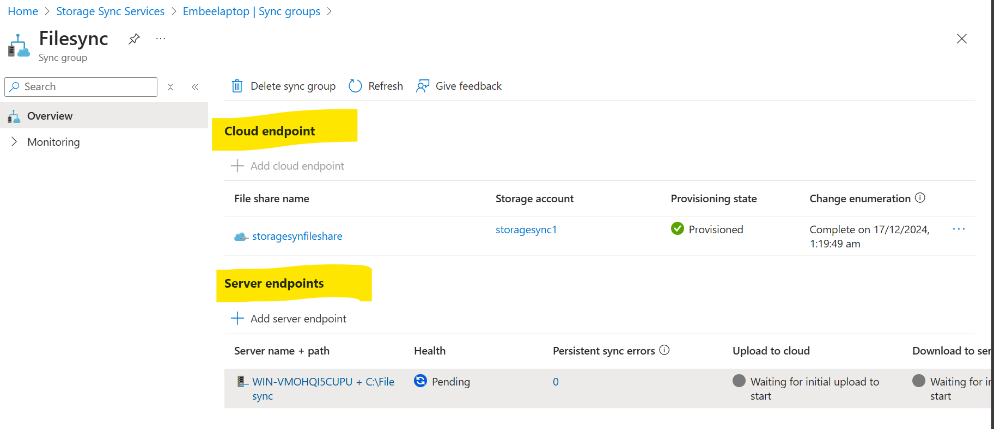
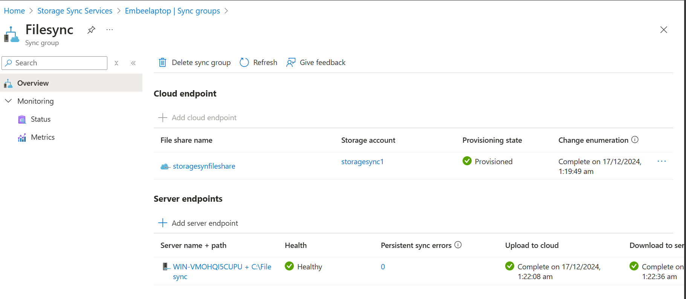

Wait for few minutes and sync will be in healthy state.

